**Dependent task scheduling using a multi**-**objective wolf pack search algorithm in** **satellite multiaccess edge computing**

Ruipeng Zhang, Yanxiang Feng, Yikang Yang*, and Xiaoling Li

## ISL distance model

The satellites in the LEO constellation are always moving at high speed. There is a significant difference in ISL distance variation between co-orbiting and hetero-orbiting satellites. Therefore, we derived the equations for the ISL distance *lc*,*d*(τ).

We use the kinematic approach to describe the relative motion between two satellites. Table 1 shows some symbols used in this subsection.

**Table 1**

Orbit elements and definitions

|  |  |
| --- | --- |
| Orbit elements | Definition |
| *a* | Semimajor axis |
| *e* | Eccentricity |
| *i* | Inclination |
| *Ω* | Longitude of the ascending node |
| *ω* | Argument of periapsis |
| *f* | True anomaly |
| *E* | Eccentric anomaly |
| *M* | Mean anomaly |
| *n* | Mean motion |
| *u* | Ture longitude |
| λ | Mean longitude |

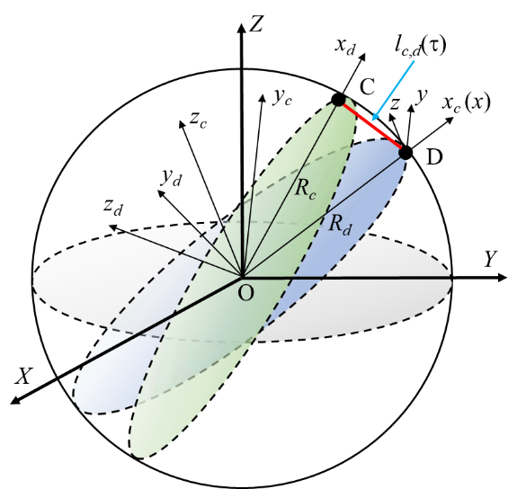

Fig. 1. Relative motion between two satellites

Fig. 1 shows the coordinate system. According to [1], the relative motion can be expressed in the local-vertical-local-horizontal (LVLH) frame of satellite C as follows:

 (1)

where R*d* (resp. Rc) are the distances from satellite D (resp. C) to the center of the Earth. ***M****CO* and ***M****DO* are the direction cosine matrices of the LVLH frames of the two satellites with respect to the inertial frame. By importing satellite orbit elements, we have

 (2)

According to the orbital geometry, the semimajor axis *a* of each satellite is equal, and the eccentricity *e* is close to zero. Δ*u*, Δ*i*, and Δ*Ω* are small quantities among adjacent satellites, and the higher-order terms can be omitted. Then we can approximate *R*, *E*, *f*, and *u* as follows:

 (3)

 (4)

 (5)

 (6)

Based on Equations (3) - (6), Equation (2) can be reformulated as (7):

(7)

Given the mean anomaly, where *M*0 is the mean anomaly at the initial moment, and τis the elapsed time. Thus, we have

 (8)

Finally, we can calculate the ISL distance *lc*,*d*(τ) by Equation (9):

** (9)

## ISL transmission model

The main source of transmission loss for ISLs is free-space transmission, which is mainly determined by the distance between the ISLs. According to Shannon formula and [2], we can obtain the relationship between channel capacity *C* and ISL distance *d*:

 (10)

where *B*is the channel width, *pt* is the transmitting power of the transmitter, *gt* (resp. *gr*) is the antenna gain of the transmitter (resp. receiver), *λ* is the signal wavelength, and *N*0 is the noise power spectral density of the ISL in the Gaussian channel.

For simplicity, we assume that the channel capacity is proportional to the bandwidth. Thus, we have

 (11)

where *δ* is the attenuation coefficient, *Q* = *δB*, and . Since the LEO satellites are connected to each other using laser ISLs, the equivalent isotropically radiated power (EIRP) *eirp* = *pt* × *gt* is significantly greater than other parameters. Considering the actual bandwidth of the laser ISL, we set *Q* = 0.289 and *K* = 1 × e7.

## Basic of Petri Nets

A PN is a four-tuple *N* = (*P*, *T*, *F*, *M*), where *P* is the set of places, *T* is the set of transitions, and *P* and *T* are finite and disjoint sets. *F* ⊆ (*P* × *T*) ∪ (*T* × *P*) is the set of directed arcs.

For any node *x*∈ *P*∪*T*, •*x*={*y* ∈ *P* ∪ *T* | (*y*, *x*) ∈ *F*} represents the preset of *x*, and *x*• = {*y* ∈ *P* ∪ *T* | (*x*, *y*) ∈ *F*} means the post-set of *x*. A marking or state of *N* is a mapping *M*: *P* → ℤ+, where ℤ+ = {0,1,2,…}. Given a place *p*∈*P* and a marking *M*, *M*(*p*) denotes the number of tokens in *p* at *M*. A Petri net *N* with an initial marking *M*0 is denoted by (*N*, *M*0).

For a given transition *t*∈*T*, if ∀*p*∈•*t*, *M*(*p*)>0, we say that *t* is *enabled* at marking *M* and is denoted by *M*[*t* >. An enabled transition *t* can be *fired* at *M*. We let the marking *M*′be the new state of Petri net*N* after *t* fired and is denoted by *M*[*t* >*M*′. The change in tokens in place *p* can be divided into three cases: for ∀*p*∈•*t\ t*•, *M*′(*p*) = *M*(*p*) −1; for ∀*p*∈*t*•*\* •*t*, *M*′(*p*) = *M*(*p*) + 1; otherwise, *M*′(*p*) = *M*(*p*). A sequence of transitions α = *t*1*t*2…*tk* is *feasible* at marking *M* if there exists *Mi* [*ti*>*Mi+1*, *i* = 1, 2, …, *k*, where *M*1 = *M.*

# REFERENCES

1. S. R.Vadali, “An analytical solution for relative motion of satellites,” in *Proceedings of the Fifth International Conference on Dynamics and Control of Structures and Systems in Space*, pp. 1-8, July 2002.
2. B. Maruddani, and W. Dara, “Ka-Band Satellite Link Budget for Broadband Application in Tropical Area,” *J. Commun.*, vol. 14, no. 7, pp. 622-628, 2019.